|  |
| --- |
| *Technical Design Specification* |

|  |  |  |  |
| --- | --- | --- | --- |
|  | Name | Role | Date |
| Author | Raju Lakide | ABAP Technical Consultant | 09-01-2025 |
| Reviewer |  |  |  |

Contents

Index of Changes 3

1. Purpose and objective 4

2. Type of Specification 4

3. Document References 4

4. Technical Design 4

4.1. Technical Design Summary 4

4.2. Data Dictionary 4

4.3. Transaction 4

4.4. Classes 5

4.5. BadI 5

4.6. Other Kind of development 6

4.7. Error Condition Handling 6

4.8. Additional Information 6

Index of Changes

|  |  |  |  |
| --- | --- | --- | --- |
| Date | Version | Description of Change | Author |
| 09.01.2025 | 1.0 | Developed a new report for PR/NFA Ageing | Raju L |
|  |  |  |  |
|  |  |  |  |

# Purpose and objective

# This document describes to creating info records based on plant material validity from & to dates

# Type of Specification

|  |  |
| --- | --- |
| Program type: | Report (read only)  Update function    Utility  Enhancement (user-exit, BADI, function module)  Modification  SAP GUI Dynpro  Web Dynpro  Interface  Inbound  Outbound  BW extractor  Smartforms |

# Document References

|  |  |  |  |
| --- | --- | --- | --- |
| Ref. | Document Name | Version | Remarks |
|  |  |  |  |

# Technical Design

Technical Design Summary

**Decommission event.**

Based on the business requirement, developed a custom report for PR/NFA Ageing

**PR-Logic:**

**Input Screen**

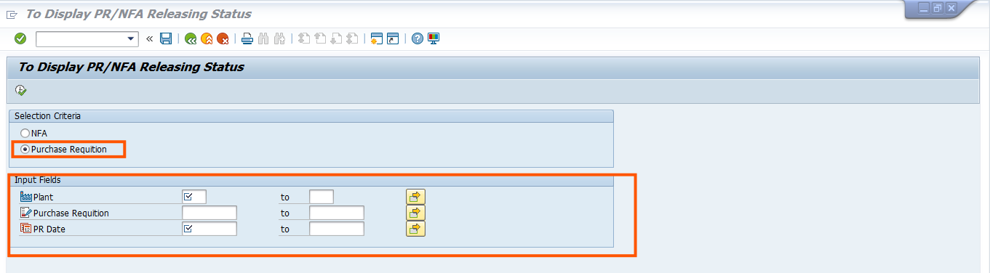

Based on the user input, passing plant, pr and date into EBAN table and getting document type, release strategy and release group, PR creation date.

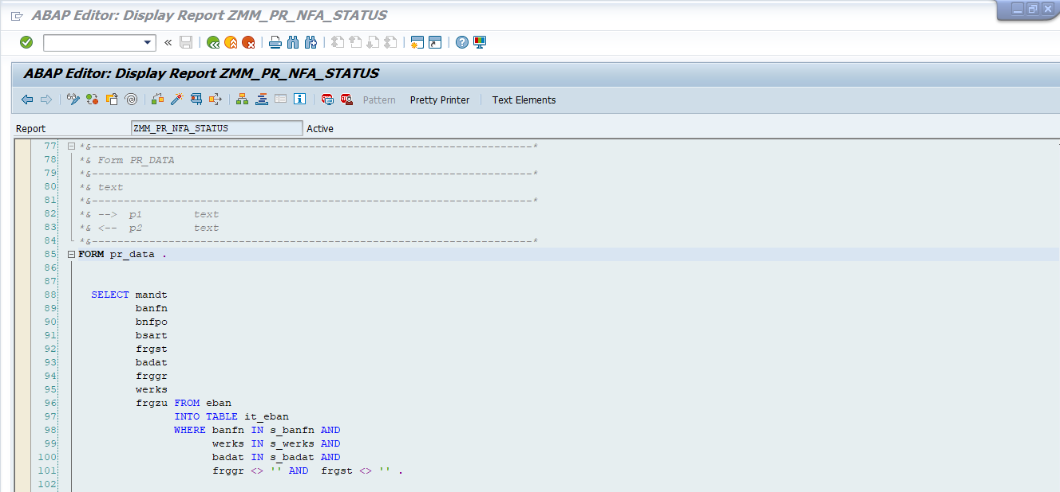

Here, Passing the eban-pr number into CDPOS table along with object class = BANF and field name = BANPR,value_new = 05 getting PR final release date

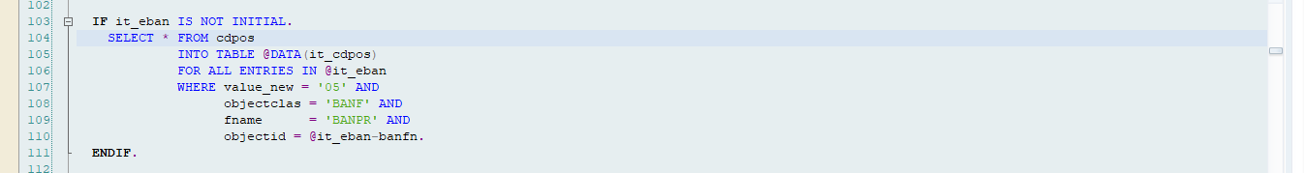

Here Passing pr and object class = BANF and fname = FRGZU getting change number document

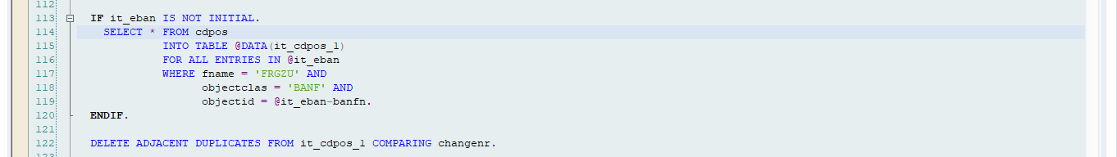

Passing the Change document number CDHDR table getting the PR release dates

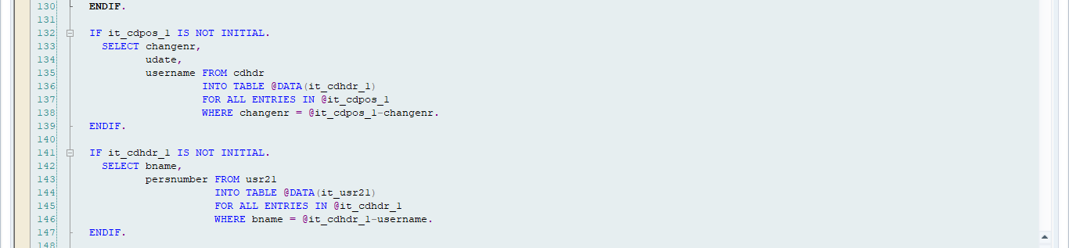

Here Passing the change document number into USR21 table getting user name in master record



Here passing the username into ADRP table getting the User name

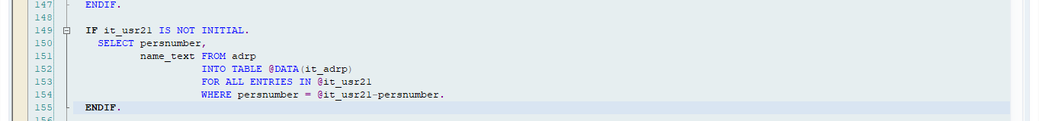

Here Passing the release strategy and release group into T16FV table getting release codes

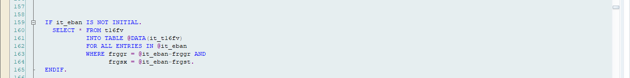

Here calculating the PR Ageing based on PR creation date & PR 1st release date similarly pr second level release – pr first release etc…

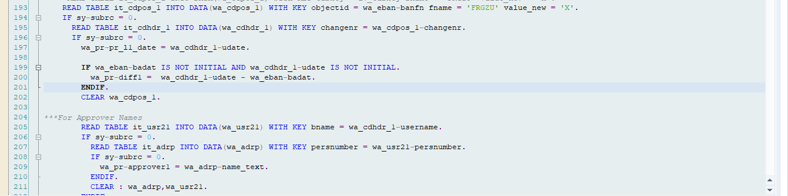

Here displaying the release codes based on PR release levels

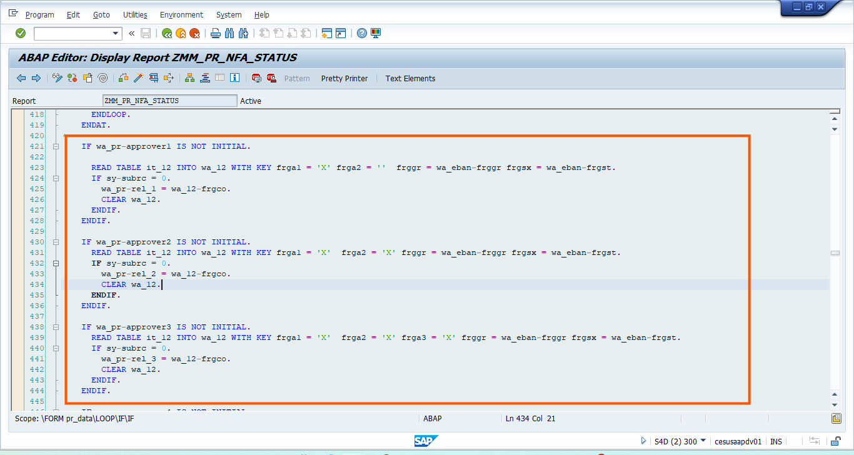

**OutPut:**

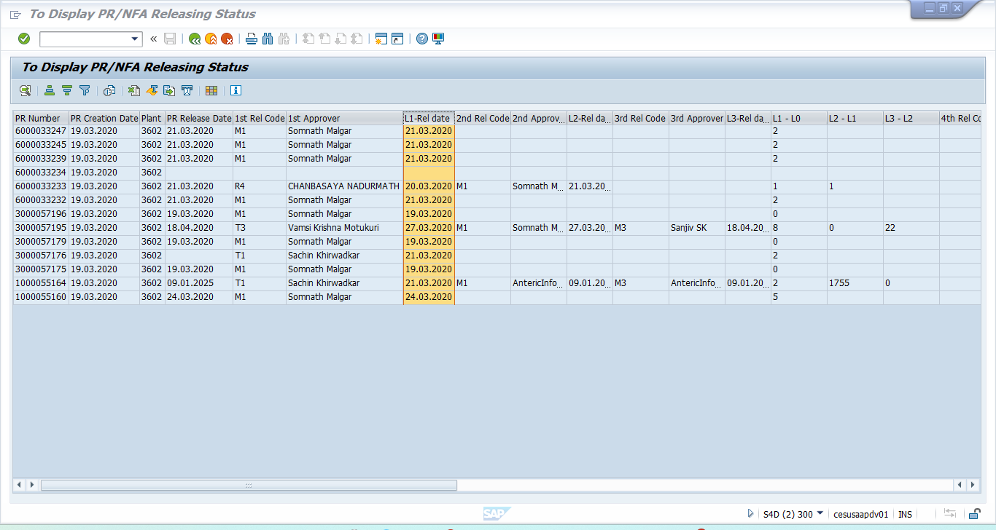

**NFA-Logic**

**Input-Screen**

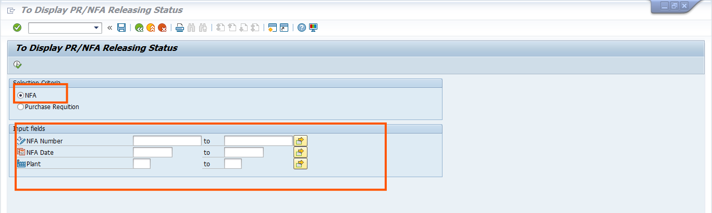

Based on the user input, pass the values into znfa_detentity table get the nfa number & plant

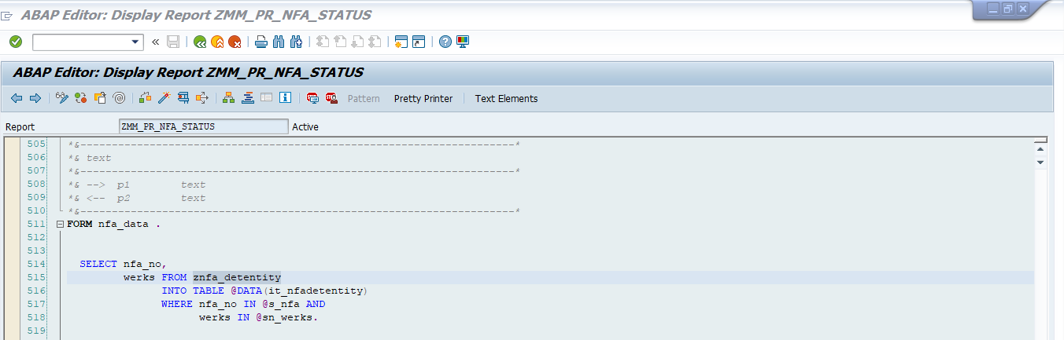

Pass the NfA no into ZNFA table getiing the NFA creation date

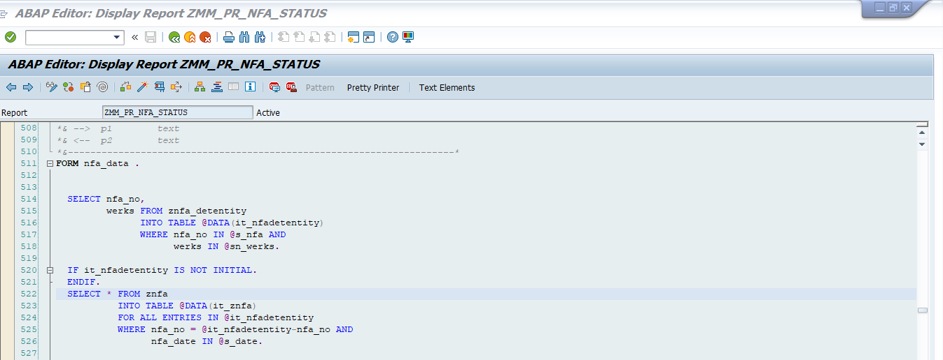

Here Passing the NFA number into table znfa_rel_tab and getting the approver date and release sequences



Here Passing the release tab approver into usr21 table getting the user name in master record

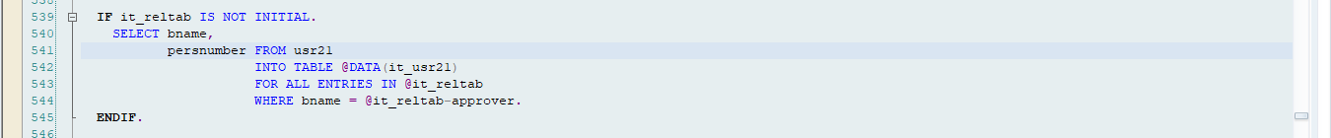

Passing user name into ADRP table and getting the approver name

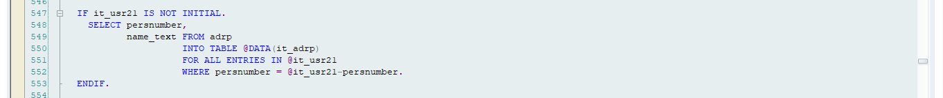

Here passing the NFA Ageing based on approver dates and average days

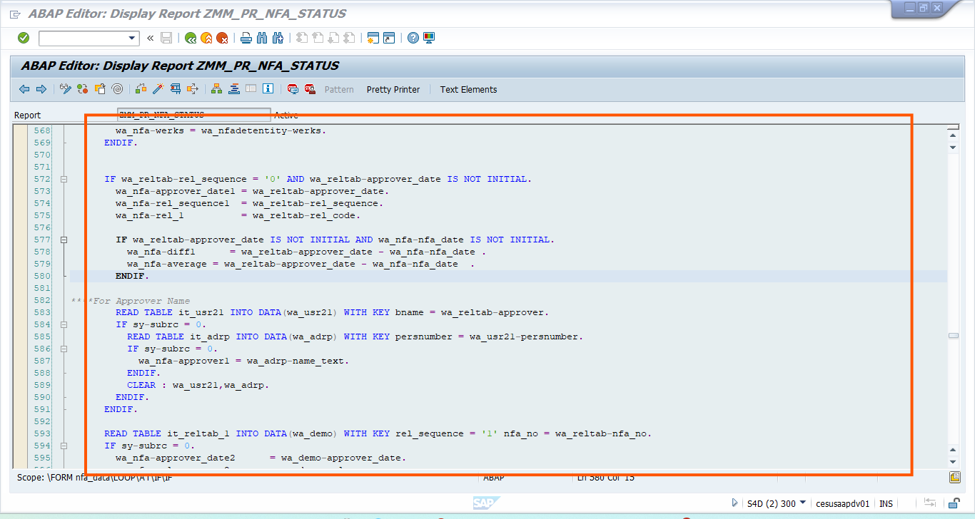

**OUTPUT:**

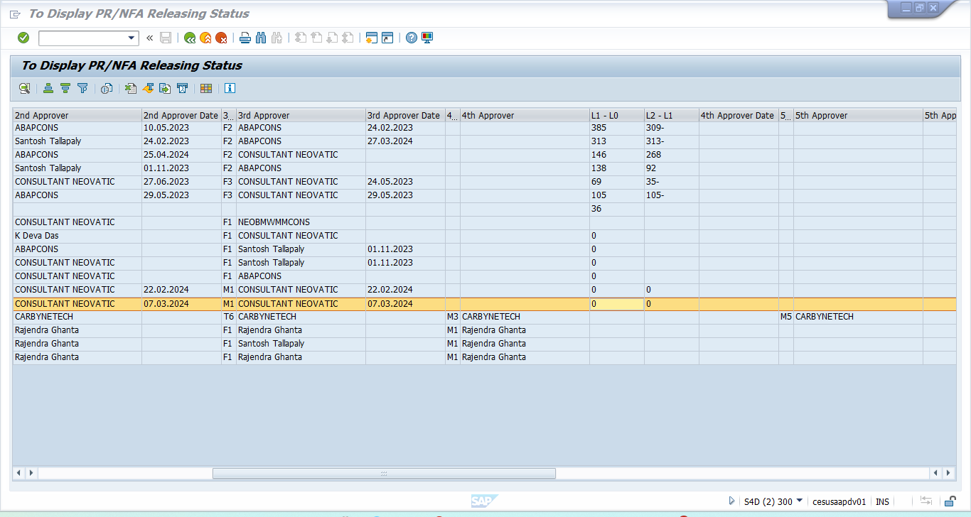

T-Code: **ZPA**

Data Dictionary

n/a

Classes

]] **Class**

BadI

n/a

Other Kind of development

n/a

Error Condition Handling

n/a

Additional Information

n/a